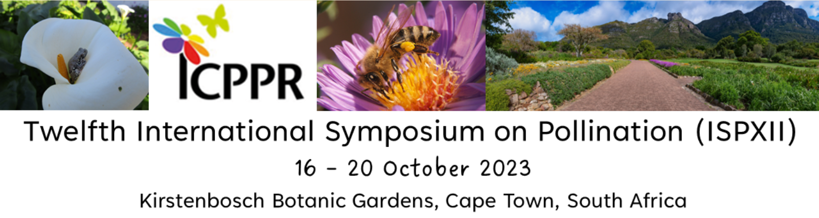

ABSTRACT SUBMISSION QUESTIONNAIRE FORM

Please complete one form per submission and email with your submission to Kerry Firmani – Kerryf@turnersconferences.co.za

Abstract Title
Presenting Author Full Name
Presenting Author Telephone
Presenting Author Email
Submission Type | ORAL |  |  | POSTER |  | POSTER TOUR (2 MIN)
Please indicate theme or topic preference | Floral signals  Apivectoring  Variation in diet and diet width in bees  Non-Apis pollinators of crops  Crop pollination by honey bees  Pollination of tropical crops  Traditional knowledge and pollination  Citizen Science  Climate Change & Land use effects on pollinators  Pollinator taxonomy  *General Oral Presentations
If You Have Selected Oral Presentation and Your Abstract Is Accepted for Poster Presentation Will You Still Be Willing to Attend and Present |  |  |  | YES |  | NO
Has Your Submission Been Approved by All the Authors |  |  |  | YES |  | NO
Please enter the authors names and which no. affiliation/s they belong to.  Please mark the presenting author with an asterisk (*) | AUTHOR NO. |  | TITLE |  | FIRST NAME/S | LAST NAME
 | 1
 | 2
 | 3
 | 4
 | 5
 | 6
 | 7
 | 8
 | 9
 | 10
Please enter the authors affiliations  Please mark the presenting author with an asterisk (*) | AUTHOR NO. |  | AFFILIATION |  | CITY | COUNTRY
 | 1
 | 2
 | 3
 | 4
 | 5
 | 6
 | 7
 | 8
 | 9
 | 10
Please provide a short biography (max 150 words) for the presenting author
Has this abstract been previously presented or included in a written publication elsewhere? If yes, please provide further information.
Do you agree to your abstract possibly being published on the website, in the final programme book or on a memory stick? | YES |  |  |  | NO

