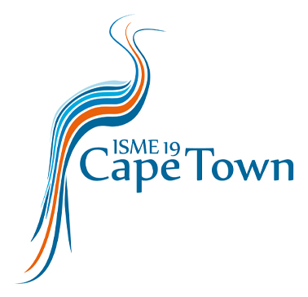

ISME EVENTS
DROEVENDAALSESTEEG 10
6708 PB WAGENINGEN THE NETHERLANDS
Tel: +31 (0)317 473 466
E-mail: events@isme-microbes.org

Declaration of studentship (PhD/Bachelor/Master) 2024

By filling in this form, the student and his/her/their supervisor declare that the student is indeed registered as a student at the University mentioned below, for most of the year 2024*; therefore, having the right to a reduced fee (Student Non Member or Developing Country Student Delegate) for the 19th International Symposium on Microbial Ecology, to take place in Cape Town, South Africa, from 18 - 23 August 2024.

To be filled in by the student:
Name:
E-mail:
University/Institute:
City & Country:

To be filled in by the supervisor:
Title & Name:
E-mail:

Telephone number:

Signature student: Signature supervisor:

----------------------------------------- ---------------------------------------

Date:
Place:

University stamp (if applicable, or other
University document):

*Most of the year indicates you are registered as a student at your university for at least six months or more in 2024.

