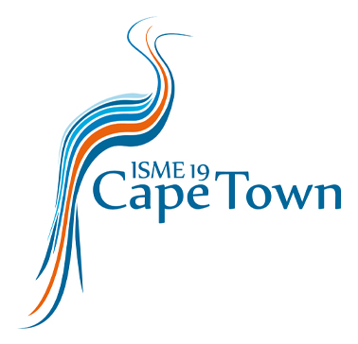

ISME EVENTS
DROEVENDAALSESTEEG 10
6708 PB WAGENINGEN THE NETHERLANDS
Tel: +31 (0)317 473 466
E-mail: events@isme-microbes.org

Declaration of status Postdoctoral Researcher 2024

By filling in this form, the postdoctoral researcher and his/her/their supervisor declare that the postdoc is indeed registered as a postdoc at the University/Institute mentioned below, for most of the year 2024*; therefore, having the right to a reduced fee (Postdoc Non-Member) for the 19th International Symposium on Microbial Ecology, to take place in Cape Town, South Africa, from 18 - 23 August 2024.

To be filled in by the postdoc:
Name:
E-mail:
University/Institute:
City & Country:

To be filled in by the supervisor:
Title & Name:
E-mail:

Telephone number:

Signature postdoc: Signature supervisor:

----------------------------------------- ---------------------------------------

Date:
Place:

University stamp (if applicable, or other
University document):

*Most of the year indicates you are registered as a postdoc at your university/institute for at least six months or more in 2024.

